RDC assignment (SC19B120 - Karun Mathews Manoj)

I hav assumed ‘x’ to be Rx. The ***input Rx***, is the input x value, and the ***measured Rx*** is the measured ‘x’ value, which we get from the measured values T1 and T2.

Explanation of working of: Direct microcontroller approach for single-element resistive

sensors

1. pin 9, 10 are set as high impedance output (open ckt) and pin 4 is set to high voltage output. Now the capacitor charges.

2. For discharging: Once the capacitor has been charged, make pin 4, 9 as high impedance output and pin 10 as low voltage output. The capacitor discharges through pin 10.

**Remember**: while discharging: Vc(t) = Vc(0)*(e^-t/ReqC). [Vdd=Vc(0) i think]

- the discharging happens only till Vc(t)=Vtl, (once the capacitor discharges to this level, the microcontroller sets pin 4 as high output and the capacitor begins charging again).

T1 = Req*C*ln(Vdd/Vtl)

3. again we charge the capacitor: make pin 9, 10 high impedance output (open circuit) and pin 4 as high output.

4. now we discharge through pin 9 by making it low, and the other pins as high impedance..

T2 = Req*C*ln(Vdd/Vtl)

These are the .meas statements i use to measure discharge time:

.meas TRAN tmpo MAX V(Vc) TRIG V(Vc)=0.3 RISE=1 TARG V(Vc)=1.25 FALL=1

.meas TRAN tdis TRIG V(Vc)=tmpo RISE=1 TARG V(Vc)=1.25 FALL=1

Here, tmpo is the maximum Vc seen during the first charge and discharge cycle

& tdis is the discharge time during the first charge discharge cycle of the capacitor.

Note: I am considering the discharge time only till Vc=1.25V instead of 1.2V, because otherwise the measurement fails.

**Required**: A charging time of 5ms. <-(pulse width)-> T = 0.69*RC (approx)

This is the charging time provided by the pulse given at the output of the monostable multivibrator. The below R, C, R1, R2 are the values of the components which are part of the monostable vibrator.

actual formula: T = RC*ln(1 + R2/R1)

taking R2=R1=1k ohm and R=750 ohm and C= 10uF. (we get a pulse of width 5ms)

we need to increment (and decrement) Rx1 and Rx2 (from 100 to 1000 & 1000 to 100 respectively) in steps of 50 ohm

x = Rx1/Ro - 1; [since, Rx1 = (1+x)*Ro]

so we start from x=-9/11; and we add + 1/11 each iteration. so totally 19 iterations (upto x=+9/11).

**The circuit diagram:**

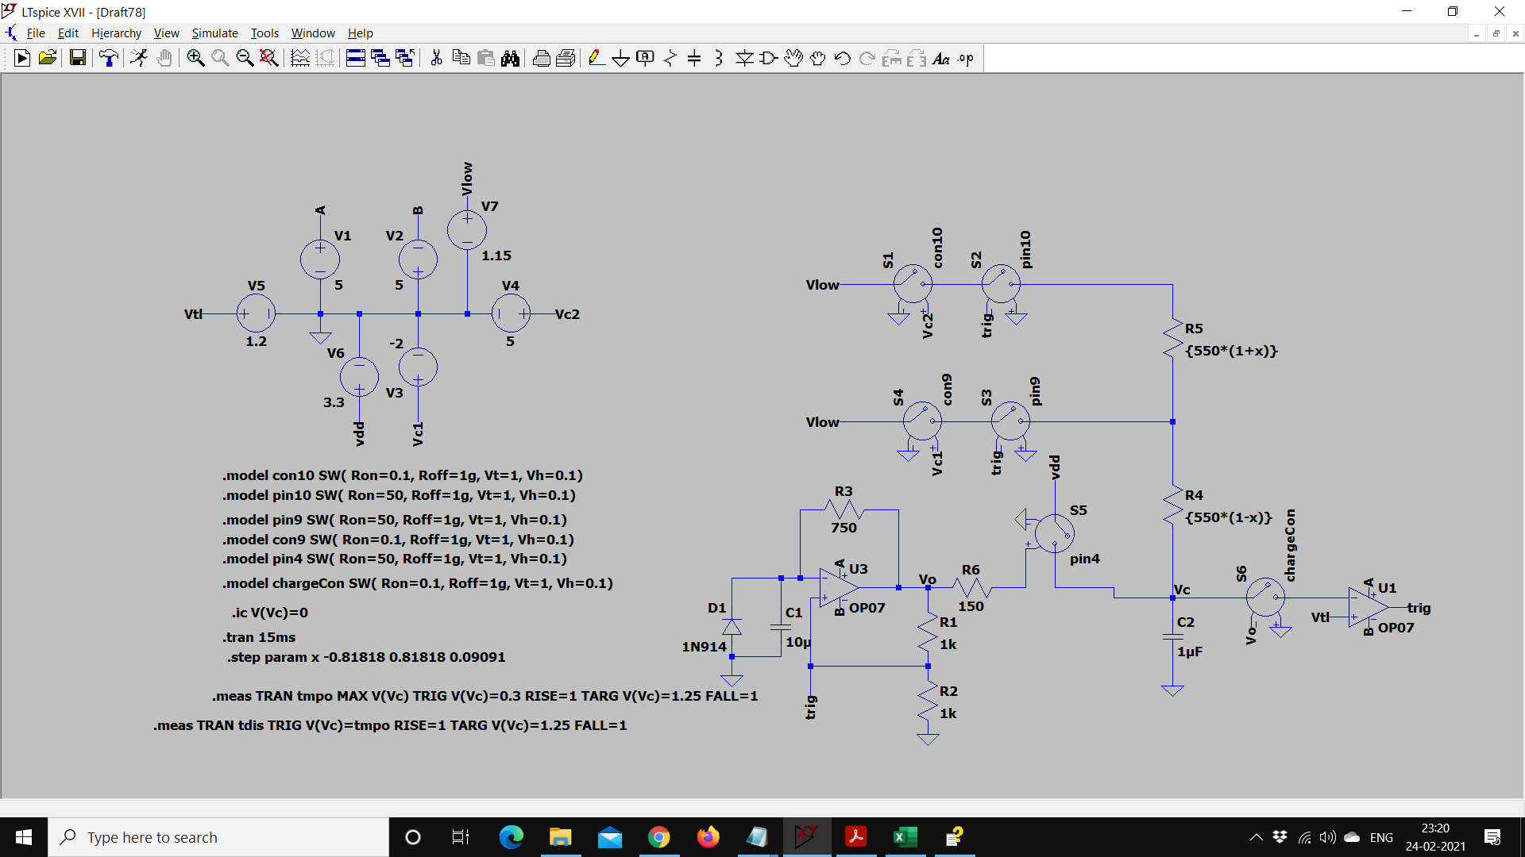

In this configuration the capacitor will discharge through pin10. If we set V3=5V and V4=-2V (the other way around), the capacitor will discharge through pin9.

If there is a mismatch between the microcontroller pin resistances of 10 ohm, we can simply set the Ron resistances of pin10 as 60 ohm and pin9 as 40 ohm. (Remember, these pins are modelled by voltage controlled switches).

Note: I will not put the pictures of the circuit diagram for all the cases as it will become too cluttered, and the diagram is almost the same. I will just show the pictures of the Vc transient output response, and the values of discharge time measured using the .meas statements.

**Given values:**

Rx1 = 100 ohm to 1000 ohm, Rx2 = 1000 ohm to 100 ohm, Ro=550 ohm, step size of 50 ohm.

(x ranges from -0.81818 to +0.81818)

Below are the results of the simulation for all the cases:

Case A and B: there is no mismatch between the pin resistances (all pins have 50 ohm resistance). The following two diagrams show T1 and T2, respectively.

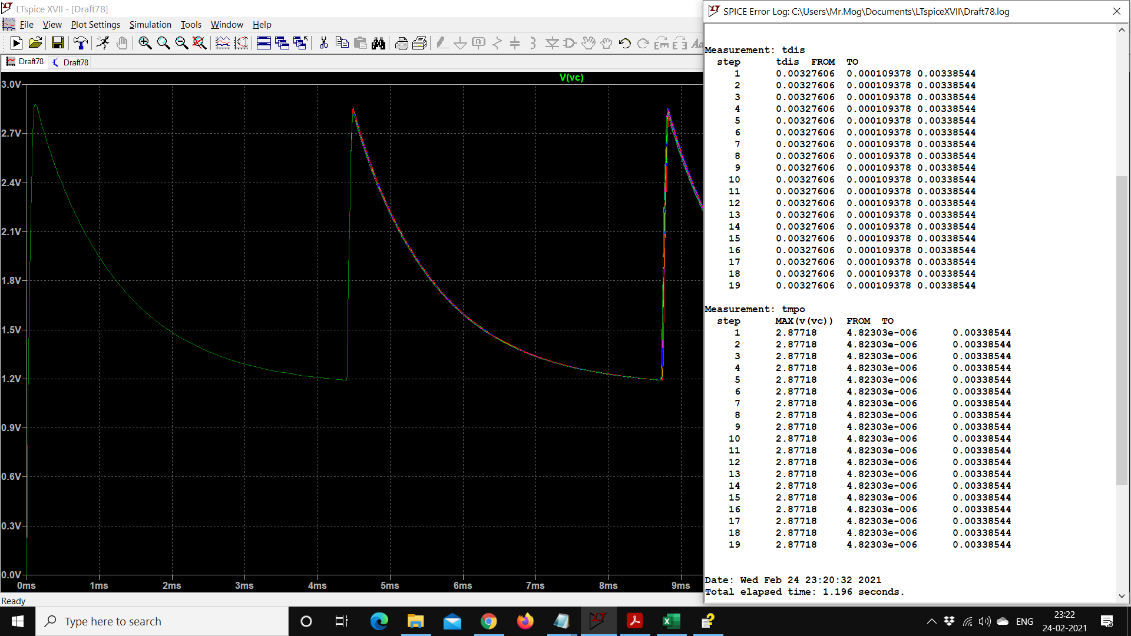 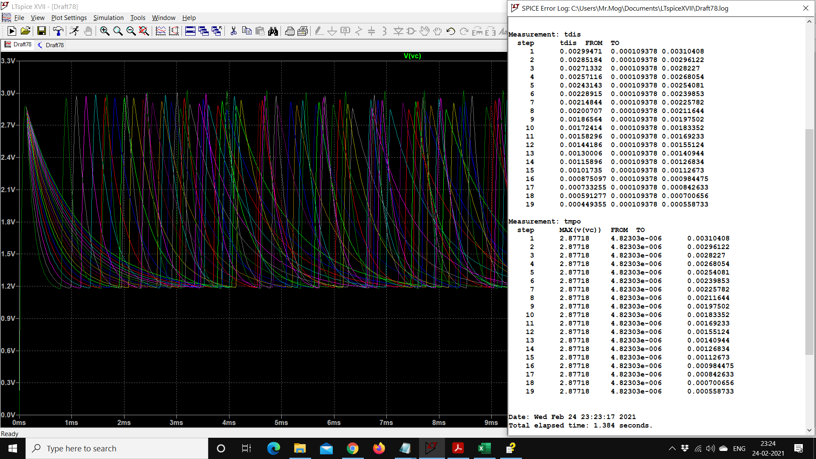

Case C and D: there is 10 ohm mismatch between the pin resistances (pin 4: 50 ohm, pin 9: 40 ohm, pin 10: 60 ohm). The following two diagrams show T1 and T2, respectively.

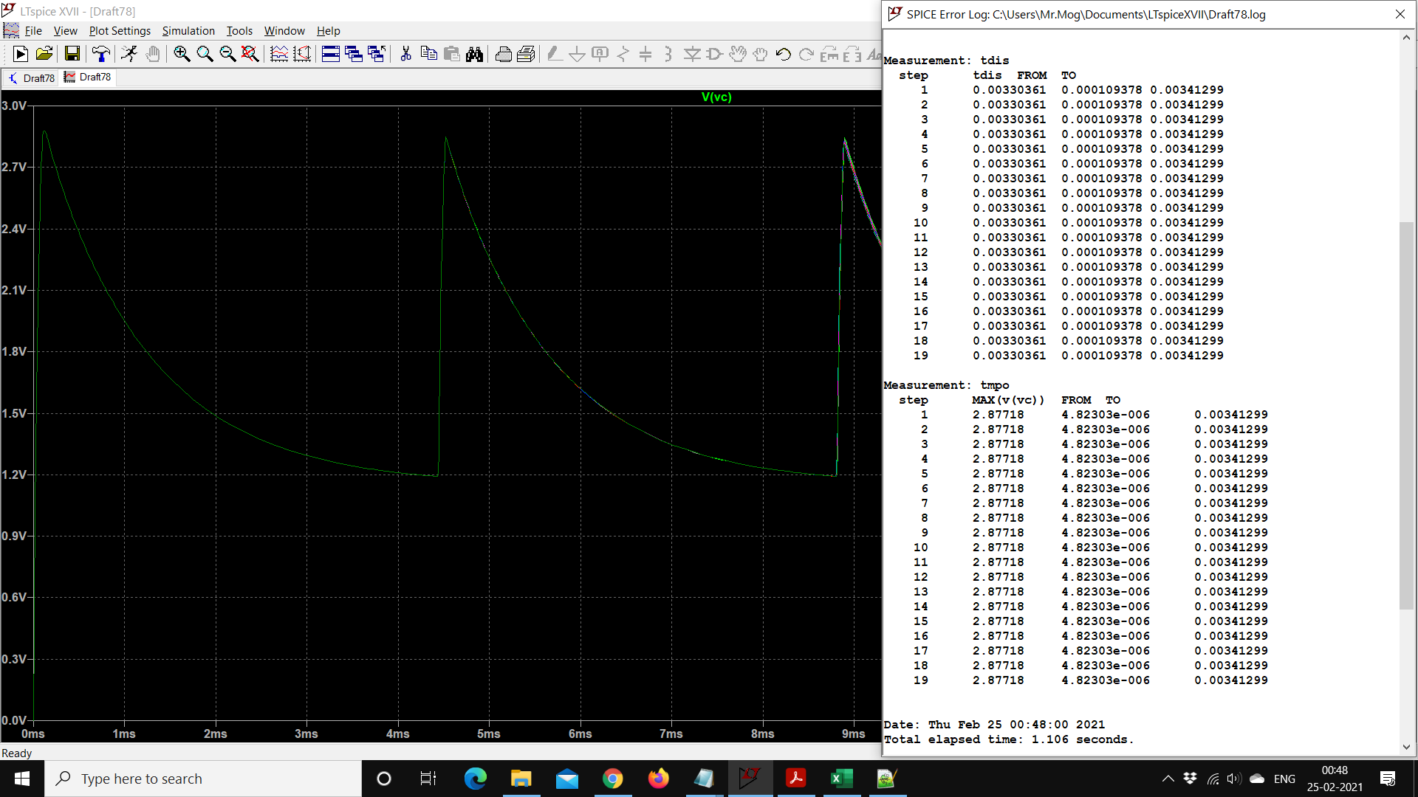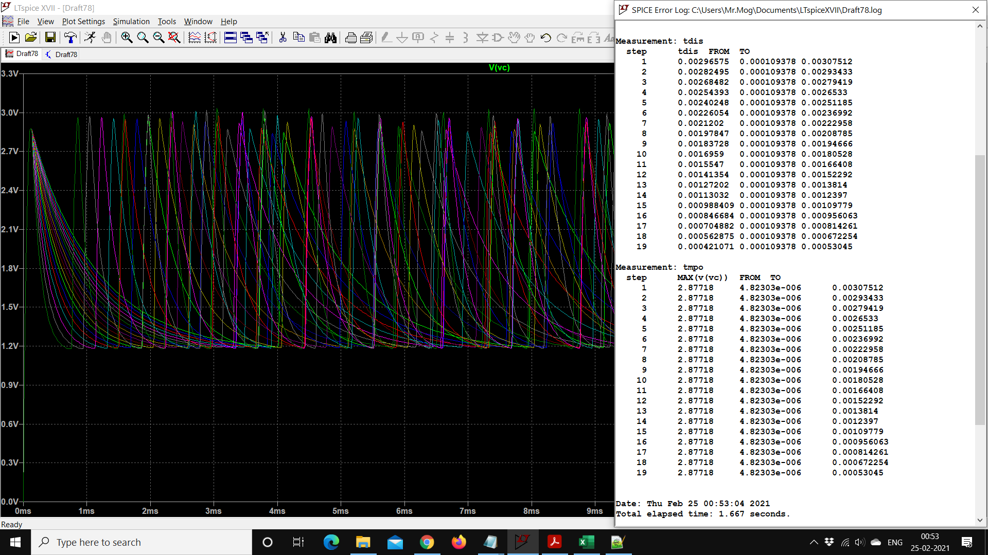

**Inferences from the simulation:**

1. we do not get the maximum capacitor voltage as 3.3 V as expected, even though it is in series with a 3.3V voltage source, while charging. In my opinion this may be because of a drop in voltage across switch s5 (modelling pin4) - which has a significant resistance of 50 ohm.

2. the discharge time decreases when you lower Vlow. It is seen that when we vary Vlow from 1.2V to 0V, tdis goes from ~4ms to ~1ms.

3. the open switch resistance, for all the switches, must be set appropriately high - so that the voltage controlled switch more accurately models an open switch.

4. when Vlow is equal or greater than 1.2V (and less than the maximum value of Vc (after charging)), it is seen that there is only one charging and discharging cycle. If Vlow is less than 1.2V, we have multiple charging and discharging cycles.

5. Since the discharge times (T1 and T2) for my given values of Rx1, Rx2, Ro and C is of the order of a few milli seconds - rounding the discharge time in microseconds, doesn’t really affect the values calculated based on T1 and T2, such as Rx1/Rx2 = F, x or %Non linearity - as is seen from the tables and graphs given in the attached file “RDC assignment relevant tables and graphs”.

6. Between the two cases of no pin resistance mismatch and 10 ohm pin resistance mismatch – the 10 ohm pin resistance mismatch system offers lower %Non linearity (0.0715% as compared to 0.097778%).

7. There is a significant amount of difference between the measured and actual (input) values, this difference increases as we increase the value of the input resistance Rx.

Formula for %Non linearity:

%Non linearity = {max(Rx(measured) – Rx(best fit))/(max(Rx(input)) – min (Rx(input)))}*100

Where, Rx = x.

%Non linearity gives us an idea of how much the measured value of Rx varies from the input Rx (which we set). And from the graphs it’s clear that Rx (measured) varies non-linearly with respect to Rx (input).

Note:

1. I assume rounding to microseconds to mean that the discharge time should be expressed in seconds with accuracy upto seven decimal places.
2. I have rounded Rx (x value) (measured) to 5 decimal places for ease of calculation.